Classroom Guidance Lesson Plan
Sunset Ridge Elementary
Mindy Willard

Teacher/Grade Second Grade
Date:
Lesson Topic: Soda Pop Head

Objectives

Obj: To identify anger buttons or triggers

Obj: To identify ways to calm down

Obj: To understand the consequences of losing control of our anger.

ASCA Standards

PS:B1.3 Identify alternative solutions to a problem

PS:C1.10 Learn techniques for managing stress and conflict

2nd Grade Standards

Materials- Soda Pop Head book, Soda Pop Head worksheet (attached), 2 balloons, can of soda (optional), small strip of paper for each student.

Pre Assessment: Give me a thumbs up if you think its okay to get angry. Tell your neighbor three ways to control your anger.

Anticipatory Set:
- Show students can of soda. Ask students to share some things that make them angry, each time shake the soda. After several, hold soda over someone’s head and ask them if they’d like you to open it. (NO!) Ask why not? (it’ll explode).
- Talk about how our anger is like the soda in the can. When we keep it inside, it will eventually explode, then it is no good to anyone.

Activity I – Read Soda Pop Head
- Ask questions for understanding during story.

Activity II – Balloon Activity
- On slips of paper, students write things that make them mad.
- Go around the room and have students share, blow up balloon a little bit each time. (anger building up inside of us)
- Before balloon pops, let the balloon go. As it soars through the air, explain that this is what happens when we control our anger and let out our fizz. We can keep our balloon from exploding if we know what to do.

Activity III- Control Your Fizz Activity
- Review advice from dad in the story. Have students draw pictures/use words to come up with ways to calm down when they are angry.

(5 deep breaths, walk away, find a quiet place, write or draw your feelings, Push Pull Dangle, listen to music, punch a pillow, go to bed on time, eat healthy) – students may have others.

Post Assessment: Thumbs up if you think it is okay to get angry. Now tell your neighbor 3 ways you can calm down when angry.

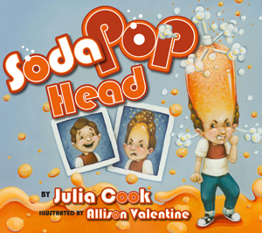
Control Your Fizz

Name ____________________________________________

Draw or write ways to “Control your Fizz” in the boxes below.

