Classroom Guidance Lesson Plan
Sunset Ridge Elementary
Mindy Willard

Teacher/Grade Third-Fifth Grades
Date: December 2012
Lesson Topic: Rudolph and Bullying

Objectives

Obj: To identify what bullying behavior looks like

Obj: To identify the roles of the bully, the bystander, and the targets.

Obj: To identify ways bystanders can make a bullying situation better.

ASCA Standards

PS:A2.1 Recognize that everyone has rights and responsibilities

PS:A1.6 Distinguish between appropriate and inappropriate behaviors.

PS:B1.4 Develop effective coping skills for dealing with problems

PS:C1.3 Learn about the differences between appropriate and inappropriate physical contact

Materials- Rudolph the Red Nosed Reindeer video (lesson plan adapted from www.schcounselor.com), Letter Head to Rudolph

Anticipatory Set:
- What is your favorite Christmas Song?
- Who knows Rudolph the Red Nosed Reindeer?
  - Let’s sing it!
- What is this story about?
  - Guide discussion to bullying
- Define Misfit

Activity I – Watch Video (48min)
- Stop movie and ask questions if possible
- Watch entire movie, ask questions at end.
- Have children take note of the bullying behaviors they saw in the movie.

Activity II – Discussion
- From birth Rudolph is told that he doesn’t fit in and has to hide his true self. Even his family is not accepting of him. How do you think Rudolph felt at this point in the movie? How would you feel if your parents did not accept something about you?

- The boss elf yells at Hermey because he says he wants to be a dentist. How does Hermey feel in that scene? What do you think Hermey should be when he grows up? What are his interests now that can help him make that decision? Name some careers that are non-traditional for males/females. How might it feel to enter into a career that is non-traditional for your gender?

- What types of bullying did you see from the other reindeer during the reindeer games? Who was the only reindeer to befriend Rudolph (Clarece). Did the adults help Rudolph? What types of bullying did you see in this scene? (name calling, isolation, exclusion) If you were one of those reindeer what would you have said or done in this situation?

- Rudolph, Hermey and Yukon Cornelius are friends to the misfit toys. How do thy help the misfit toys? (in the end of the story they help them find homes – helping others who are excluded).

- How did the very things that Rudolph and Hermey get made fun of help everyone in the end?

- Why is it important to celebrate our differences?

Activity III- Write a letter to Rudolph
a. Write a letter to Rudolph explaining how you feel about what happened to him and what you would have done if you were there during the Reindeer Games.

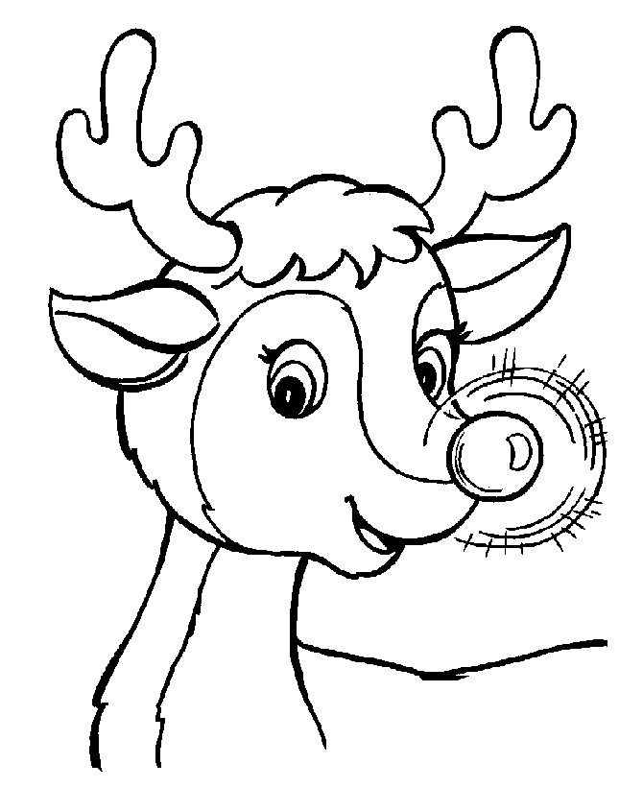

Dear Rudolph,

______________________________________________________________________________________________________________________________________________________________________________________________________________________________________________________________________________
______________________________________________________________________________________________________________________________________________________________________________________________________________________________________________________________________________
______________________________________________________________________________________________________________________________________________________________________________________________________________________________________________________________________________
______________________________________________________________________________________________________________________________________________________________________________________________________________________________________________________________________________
Sincerely,

Name: __________________________ Rudolph the Red Nosed Reindeer and Kindness
In the box below, tally the number of times you see someone being kind in this video.

- Rudolph’s family is not accepting of him. How do you think Rudolph feels at the beginning when his parents are disappointed with his red nose?
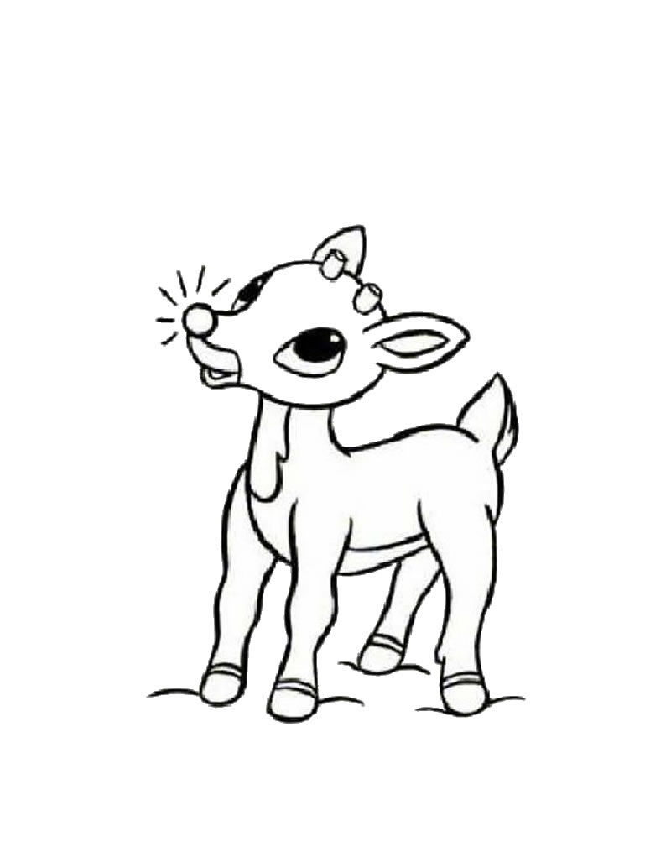

- How would you feel if your parents didn’t accept something about you?

- Hermey the Elf doesn’t want to make toys, what does he want to do instead?

- What kind of a career do you want to have in the future? Why?

- How is Hermey treated by the other elves?

- During the Reindeer Games, Rudolph is bullied by the other reindeer. What types of things do they do to him?

- What would you have done if you were there?

- Who is the only reindeer to befriend or show kindness to Rudolph? What did she do that was kind? How did that make Rudolph feel?

- Who is someone that is kind to you? What do they do that is kind?

- Who is someone that you are kind to? In what ways do you show kindness to that person?

- Rudolph chose to run away because of the bullying. What could he have done differently to handle the problem?

