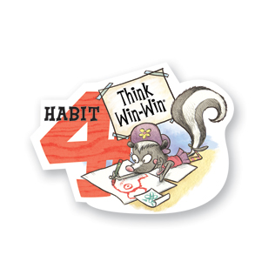
Problem Solving Worksheet
Name ________________________________
Habit 4 – “Think Win-Win”

Think of a conflict you have had in the past or one you are currently dealing with. Maybe with your brother/sister, friend or even your parents or teacher.

What do (did) you want to happen?
____________________________________________________________________________________________________________________________________________________________________________________
__________________________________________________________________________________________

What does (did) the other person want to happen?
____________________________________________________________________________________________________________________________________________________________________________________
__________________________________________________________________________________________

What are possible solutions? | Positives Outcomes of this solution | Negatives Outcomes of this solution
1.

2.

3.

4.

5.

Put a star next to the solutions that are win-win.

Which solution did you try? How did it work for you?
____________________________________________________________________________________________________________________________________________________________________________________
__________________________________________________________________________________________

If it did not work out, try another one.

