Classroom Guidance Lesson Plan
Sunset Ridge Elementary
Mindy Willard

Teacher/Grade Third Grade
Date:
Lesson Topic: Habit 5: Seek First To Understand, Then to Be Understood

Objectives
Students will understand that listening and hearing are not the same thing.
Students will understand that we listen with our hearts, eyes and ears

Students will know how to exhibit body language that demonstrates good listening skills.

ASCA Standards

PS: A2.6 Use effective communication skills

PS:A2.7 Know that communication involves speaking, listening and nonverbal behavior

3rd Grade Standards

S1C6 PO 3. Ask relevant questions in order to comprehend text.

S1C6 PO 5. Extract information from graphic organizers (e.g., webs, Venn diagrams, flow charts) to comprehend text.

S1C6 PO 6. Connect information and events in text to experience and to related text and sources.

Materials- Rabbit Puppet, 7 Habits of Happy Kids Book, Partner Cards, Listening During a Conversation Worksheet, Chinese Symbol for Listening.
Partner Cards: On index cards write one word on a card, and its partner on another (ie. Peanut Butter/Jelly, Selena Gomez/Justin Bieber)

Pre Assessment: Point to the part of your body that you use for listening.

Anticipatory Set:
- Create a Double-Bubble Map/compare contrast (on board) with the difference between Hearing and Listening. How do you know when someone has listened to what you have said? How do you show that you are listening to someone else? What sorts of things do people say and do to show they are listening?

Activity I – “Jumper and the Lost Butterfly Net”
- Read chapter 5 from Happy Kids Book and facilitate discussion questions at the end.
- Review Baby Steps at end of chapter.

Activity II – “Practice Listening”
- What does active listening look like at school? When do we need to use it? (listening to another person’s point of view, listening to a story, listening to instructions, asking thoughtful questions to the speaker).
- What does active listening look like in the real world Where/when/who uses it? (talk to your partner about this). (Waitresses listen to take orders, calling 9-1-1, family members talking about problems, listening to a movie, listening to a doctor’s instructions etc.).
- Review social skill of listening
- Look at the person
- Stay quiet
- Wait until the person is finished talking.
- Nod to show you understand
- Ask a question or repeat what they said.
- Do a practice role-play with classroom teacher or student. Demonstrate good and poor listening skills.
- Give each student a partner card. When I say “Go” you are going to walk around the room and find the person who has the card that goes with yours. When you have found that person sit on the rug together.
- Students will practice listening. “Tell your partner about how your family celebrates Thanksgiving” (or any other topic). The listener should practice the steps to listening. When time is up, restate what that person said. Then it is the next person’s turn.
- Show Chinese Symbol for Listening. Point out that listening is not just with our ears, but also with our hearts, and our eyes. Discuss with students what this means.
- Allow students to re-create the Chinese symbol on their own papers.

If Time or During Follow Up Lesson
- There is a GREAT listening activity in the Teacher’s Guide to the book The Worst Day Of My Life Ever by Julia Cook.
- There is a story book and a teacher’s guide – very affordable and great for teaching the skills of Listening and Following Instructions.

Post Assessment: Now have students point to the parts of the body used for listening.

Homework: None

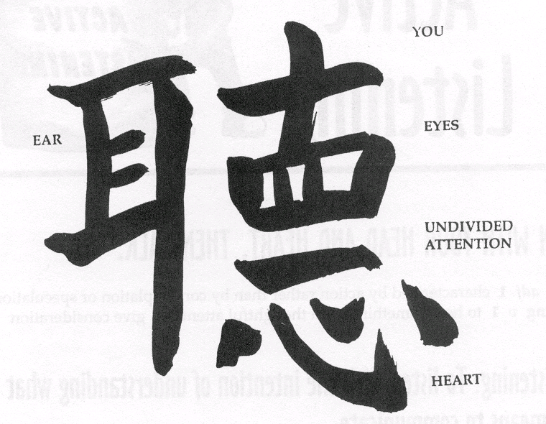
Chinese Symbol For Listening

