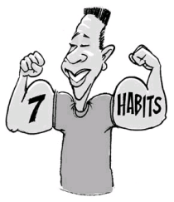
Habit 2: Begin with the End in Mind
Goal Setting Step-by-Step

Name_____________________________ Block _________
Remember to think S.M.A.R.T. when setting your goals.

Specific
Example: My goal is to save $200 to buy an IPOD for my dad by December 25 because I lost his first one.
(please write your specific goal in the space provided)

Who? What? When? Where? Why?
Measureable
Example: I will save $20 a week for 10 weeks.
(How will you monitor your goal? Ask: How often? How many? How much?
Attainable
Example: I will do extra chores and babysit to save the money.
(What are the steps you need to take to reach this goal?)
Realistic
Example: Yes, I have earned money before and know how to save it.
Is this a goal that you can achieve? How do you know?
Time
Example: I want to reach my goal by December 24, 2011
(When do you want to reach your goal?)

