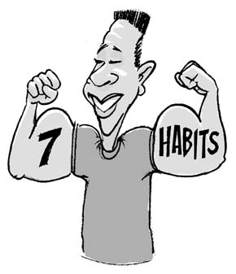
7 Habits of Highly Effective Teens
Last Name ____________________ First Name _________________
Period _____________

Chapter 1
7 Habits of Defective Teens 7 Habits of Effective Teens
“Depending on what they are, our habits will either make us or break us. We become what we repeatedly do.”

